The risks of alcohol, marijuana, and other drugs, explained
By German Lopez


Researchers have said for years that alcohol is more dangerous than marijuana. But what does that mean, exactly? And how do we know?
It's certainly not because of any government-acknowledged evaluation. The federal government's scheduling system evaluates drugs by medical value, first, and abuse potential, which is poorly defined under the law, second — but it excludes alcohol and tobacco altogether. Even if the federal classifications included alcohol and tobacco, both would likely fall in the same category as marijuana — schedule 1 — since they have no acknowledged medical use and some potential for abuse, making it hard to compare the drugs based off that.
This has left it up to researchers and drug experts to evaluate which drugs are truly the most dangerous. A 2010 study published in The Lancet, led by drug expert David Nutt, evaluated the use of 20 drugs in the UK, putting alcohol at the top of its harms rankings and hallucinogens at the bottom. Here at Vox, I've pointed out that alcohol is one of the three deadliest drugs in America.
There are big drawbacks to looking at drugs exclusively through these blunt measures. Alcohol, tobacco, and prescription painkillers are likely deadlier than other drugs because they are legal, so comparing their aggregate effects to illegal drugs is difficult. Some drugs are very harmful to individuals, but they're so rarely used that they may not be a major public health threat. A few drugs are enormously dangerous in the short-term but not the long-term (heroin), or vice versa (tobacco). And looking at deaths or other harms caused by certain drugs doesn't always account for substances, such as prescription medications, that are often mixed with others, making them more deadly or harmful than they would be alone.
For these reasons, it's nearly impossible to come up with an exact measure of a substance's harm. So I talked to drug experts about the reasons people take drugs (legal and illegal ones) and the risks behind them. Although experts generally agree that alcohol is more dangerous than marijuana, there was a lot of nuance in how they took on the issue — and there is enormous variation within what makes pot, alcohol, and other drugs dangerous. Here's a breakdown of what experts said about some of the most widely used drugs.

Alcohol

Behold, one of the most dangerous drugs in America. (Justin Sullivan / Getty Images News)
Risks: One of the biggest short-term risks to alcohol is that it can heighten the risk of accidents, particularly car crashes. One study from Columbia University researchers found that drinking and driving multiplies the chance of a fatal accident by nearly 14 times. But if someone consumes alcohol with another drug, the risk is multiplied by more than 23 times.
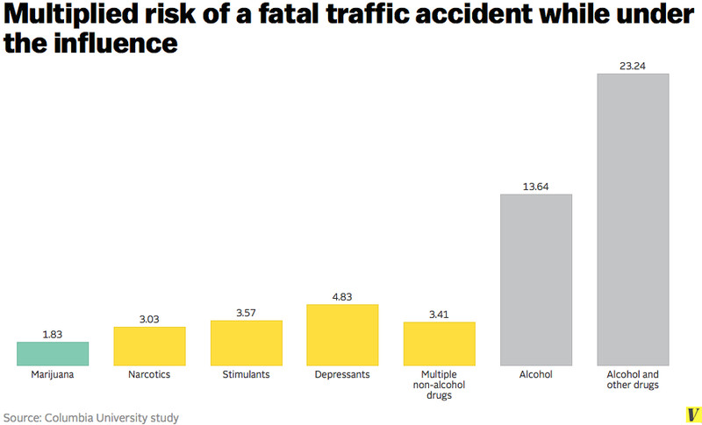
Alcohol is also capable of making people more aggressive and violent, potentially leading to more violent crime.
In terms of health risks, alcohol can lead to extensive organ damage, especially to the liver. These problems are most prominent among heavy drinkers, but can occur among lighter drinkers who consistently consume alcohol over long periods of time.
Alcohol can also heighten the dangers of other drugs. It can further increase the risk of a heart attack or stroke when mixed with cocaine. It can enhance the effects of opioid-based painkillers, raising the chance of overdose. And it can interact with antidepressants to severely hinder a person's reflexes.
Addiction is also a widespread problem, which makes it all the more difficult to deal with the other problems presented by alcohol.
Why people do it: Some people drink beer, wine, and other forms of alcohol to wind down at the end of the day. And although it's not recommended, some people use alcohol to self-medicate through tough periods in their lives.
Alcohol can also be used for medical and hygienic purposes, such as to clean wounds and hands.
Bottom line: A lot of people can use alcohol for most of their lives without having any problems with it.
But alcohol is still a public health problem. The Centers for Disease Control and Prevention estimate that excessive drinking causes 88,000 deaths each year and one in 10 deaths among working-age US adults (ages 20 to 64). Alcohol is also capable of making people more aggressive, and it's a factor in about 40 percent of violent crimes, according to the National Council on Alcoholism and Drug Dependence.

Marijuana
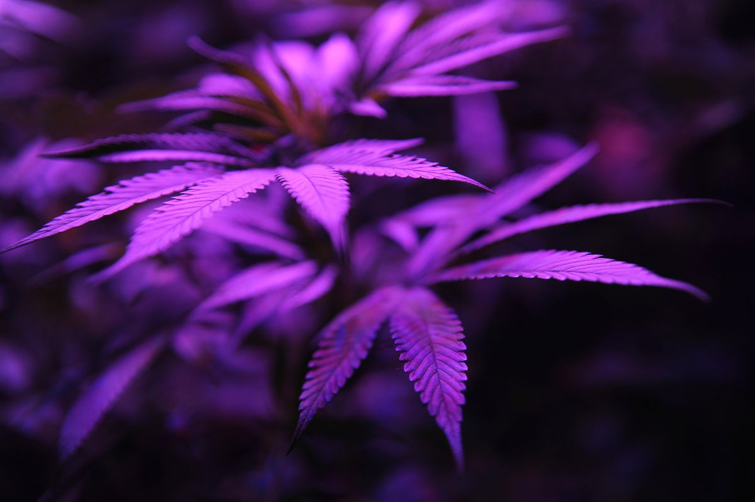
Marijuana plants under a black light. (Seth McConnell / Denver Post via Getty Images) Seth McConnell/Denver Post via Getty Images
Risks: Marijuana has never reportedly caused an overdose death, but that doesn't mean it's harmless.
"The main risk of cannabis is losing control of your cannabis intake," Mark Kleiman, a drug policy expert at New York University's Marron Institute, said. "That's going to have consequences in terms of the amount of time you spend not fully functional. When that's hours per day times years, that's bad."
Caulkins of Carnegie Mellon University put it another way: "At some level, we know that spending more than half of your waking hours intoxicated for years and years on end is not increasing the likelihood that you'll win a Pulitzer Prize or discover the cure for cancer."
The risk of abuse is compounded by the widespread perception that pot is harmless: since many marijuana users believe what they're doing won't hurt them, they feel much more comfortable falling into a habit of constantly using the drug.
A lot of research has linked adolescent marijuana use to a range of bad consequences, including cognitive deficiencies and worse educational outcomes. While it's not clear marijuana's relationship with these outcomes is cause-and-effect, it's generally agreed upon that people younger than their mid-20s should avoid the drug.
The research on other health effects of marijuana is inconclusive. Some studies linked the use of marijuana to psychotic disorders, but other research suggests people with psychotic disorders may be predisposed to pot use. And research on whether smoked marijuana causes lung disease or cancer has yielded conflicting results, with studies that control for tobacco smoking finding no significant effect from marijuana on lung cancer risk.
Marijuana also increases the chance of accidents. The previously mentioned study from Columbia University researchers found that people driving with marijuana in their system were nearly twice as likely to get in a fatal car crash. The increased risk indicates that some people likely die as a result of marijuana use every year, but it's unclear how many due to inadequate data and reporting.
Why people do it: The euphoric high from marijuana lets some people relax by enhancing everyday activities, including music, food, and sex. The research and anecdotal evidence also suggests marijuana could be used to treat several medical problems, such as pain, nausea and loss of appetite, Parkinson's disease, inflammatory bowel disease, PTSD (post-traumatic stress disorder), and epilepsy.
Bottom line: Marijuana is safer than most other drugs on this list, but it's not harmless. It can have a seriously negative impact on some people's productivity at work or school.
But many people can lead normal lives while regularly using pot. And experts largely agree that alcohol and especially tobacco are more dangerous drugs to individuals and society as a whole.

Tobacco

Behold, the deadliest substance in America. (Eric Feferberg / AFP via Getty Images) Eric Feferberg/AFP via Getty Images
Risks: Tobacco destroys the body in various ways. It is the leading cause of lung cancer, which killed more than 200,000 people in 2011. It heightens the risk of heart attack and stroke. It also increases the risk of diabetes, leukemia, cardiovascular diseases, respiratory diseases, kidney disease, and intestinal disease. And secondhand smoke can increase bystanders' risk of lung cancer and heart disease, among other issues.
Nicotine found in tobacco is hugely addictive, making it very difficult to quit even if someone knows the tremendous risks involved.
Why people do it: The slight buzz from tobacco is a cheap, legal way for some people to wind down, but it can come at an enormous cost to someone's health if used over long periods of time.
Bottom line: Tobacco is the deadliest substance in America. The CDC estimates it kills 480,000 people each year — more than all reported homicides, traffic accidents, and drug overdoses combined. Even that may undercount the death toll of tobacco: a recent study found tobacco kills 60,000 more people each year than previously estimated.

Opioid-based prescription painkillers
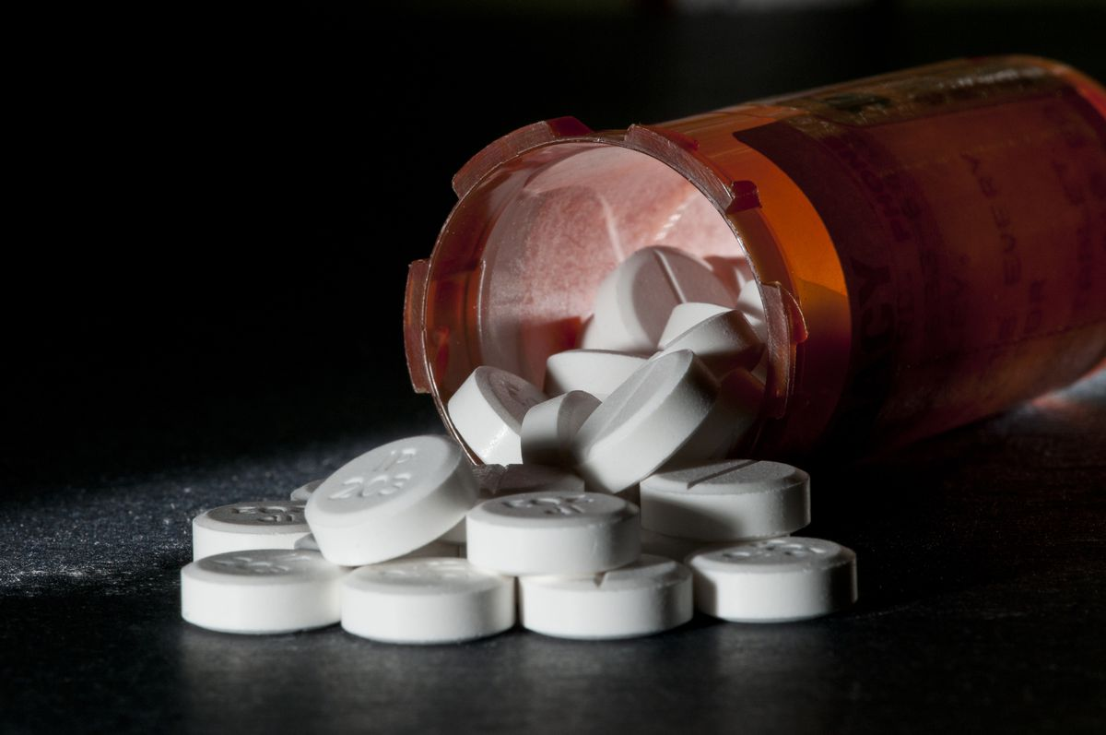
These can relieve pain, but they're dangerous — especially when paired with other drugs. (Education Images / UIG via Getty Images) Education Images/UIG via Getty Images
Risks: The most common risk of opioid-based prescription painkillers is fatal overdoses.
Overdoses tend to happen in a few scenarios. Keith Humphreys, a drug expert at Stanford University, said some people try to "chase pain" by swallowing pills until their pain is relieved, and accidentally take too many. Many users underestimate how long the drug remains in their body, and consume more pills or other drugs before they should.
People who mix prescription painkillers with other drugs increase their chances of overdose. The CDC found that 31 percent of prescription painkiller-linked overdose deaths in 2011 were also linked to benzodiazepines, a legal anti-anxiety drug. Alcohol and muscle relaxants can also increase the risk.
Other side effects of painkillers include narcotic bowel syndrome, increased risk of bone fractures, and the potential for hormonal imbalance.
Prescription painkillers are highly addictive and some people abuse them to get high. A 2014 study published in JAMA Psychiatry found that addicted patients will resort to the more dangerous heroin if their painkiller supply is cut off, since it is an opioid as well.
Why people do it: Painkillers are good at alleviating pain. This addresses a very big health problem in America: a 2011 report from the Institute of Medicine found that about 100 million US adults suffer from chronic pain, and many are under-treated for it. There's some debate, Humphreys noted, about whether painkillers are good for treating long-term pain, but they can relieve problems in the short-term.
Bottom line: More than 16,200 people died of prescription painkiller overdoses in 2013, according to the CDC. Although the drugs are often prescribed to deal with real, significant pain, they're widely misused and can lead to deadly complications.
Crack and powder cocaine
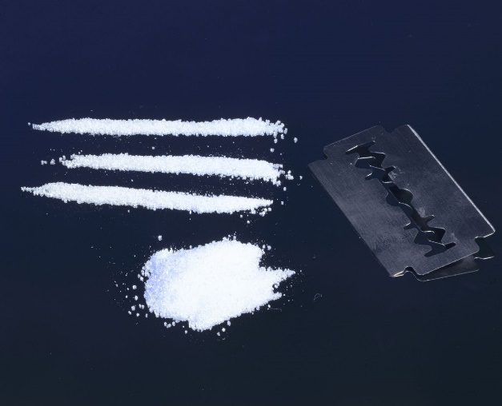
Three lines of cocaine. (SSPL / Getty Images)
Risks: Crack and powder cocaine increase blood pressure and heart rate, raising the risk of heart attack or stroke in otherwise healthy people. Both drugs can also cause psychotic episodes, potentially making someone temporarily paranoid or violent, according to George Woody, a drug expert at the University of Pennsylvania.
Crashing after the high from cocaine can also cause severe depression, which can lead to suicidal thoughts. "You see this in emergency rooms, where somebody will come in and be suicidal," Woody said. "Then you see them the next morning, and they're fine."
Cocaine can have terrible reactions with other drugs. Alcohol and cocaine can mix in the liver to form a chemical known as "cocaethylene," which can heighten the high from cocaine but also the cardiovascular risks attached to the drug.
Although crack and powder cocaine are chemically similar, there are two major differences that make crack more accessible and potentially more harmful than powder cocaine: crack is smoked, so it takes effect more quickly, and it's much cheaper.
Different forms of consumption can also bring their own medical issues. Snorting can hurt someone's sense of smell and ability to swallow. Smoking may damage the lungs. Injecting can be more dangerous, since dirty needles can carry infectious diseases like HIV and hepatitis.
Cocaine is also very addictive, exacerbating some of the issues related to it. Some people will resort to crime, such as theft or drug dealing, or sex work to make money to obtain the drug.
Why people do it: Crack and powder cocaine's temporary high makes users more energetic, attentive, and focused, though the effects can be achieved with safer, longer-lasting drugs.
Bottom line: Crack and powder cocaine can cause problems, ranging from heart attacks to violent behavior that leads to criminal acts. Neither appear to pose the same level of long-term risks of tobacco, but they can cause serious issues in the short-term.

Heroin
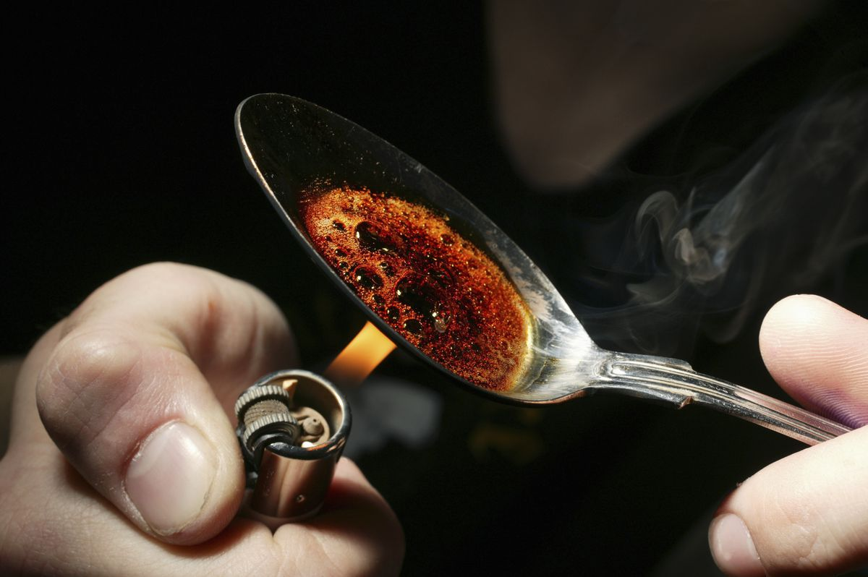
Heroin preparation. (Universal Images Group via Getty Images) Universal Images Group via Getty Images
Risks: Like prescription painkillers, the most serious risk of heroin is fatal overdoses. Humphreys of Stanford University said this risk actually increases the longer someone uses heroin, because people seem to grow tolerant to the high from heroin more quickly than the negative respiratory effects that lead to overdose.
Injecting heroin is also fairly dangerous, since dirty needles can carry a major risk of infection, particularly for diseases like HIV and hepatitis.
Heroin, similar to painkillers, becomes more dangerous when mixed with other drugs, like alcohol and cocaine. Sometimes other drugs are mixed into heroin without the user's knowledge, but Humphreys said these instances are "incredibly rare and over-hyped."
Heroin is also highly addictive, exacerbating the problems attached to it. A relapse can be a particularly dangerous event: addicts going back to the drug often try the same dose they used prior to recovery, except without the tolerance they had built up beforehand, increasing the risk of overdose.
The addiction, like cocaine, can also lead some people to crime and sex work to buy the drug.
Why people do it: Heroin can lead to a euphoric high and relieve pain, but similar effects can be reached with other drugs.
Bottom line: Although heroin doesn't possess the same long-term health risks of tobacco or criminological risks of alcohol, it's very dangerous in the short-term due to the chance of fatal overdose. The problem appears to be getting worse: heroin overdose deaths nearly doubled between 2011 and 2013, from about 4,400 to nearly 8,300, according to the CDC.

Meth
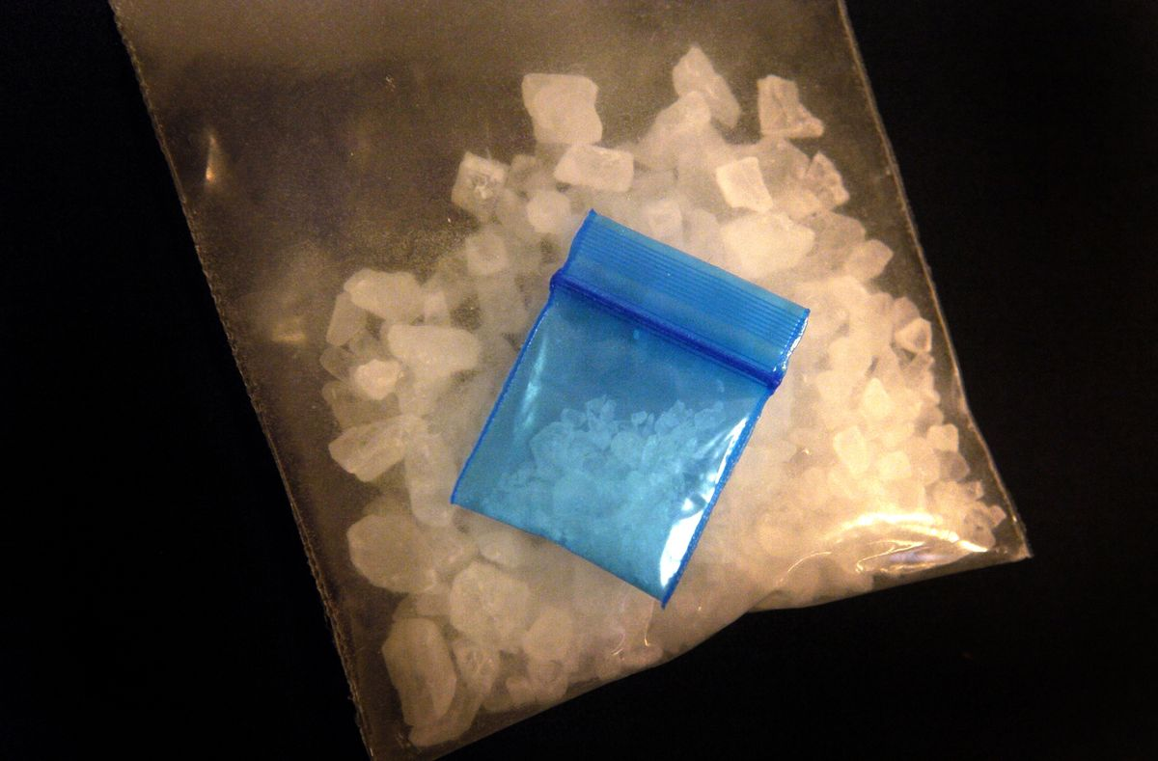
Crystal meth. (Karl Gehring / Denver Post via Getty Images)
Risks: Methamphetamine carries several short-term health and behavioral risks. It increases blood pressure and heart rate, potentially raising the risk of a heart attack or stroke. Larissa Mooney, an addiction psychiatrist in Los Angeles, said it can also make people aggressive, leading some meth users to act out through violence and crime.
Meth can also make it more difficult to sleep, which can lead to medical problems, including increased risk of heart disease, cognitive deficits, and mood swings. Various studies also found a link between meth use and cognitive impairments. In extreme cases, meth can lead to paranoia mimicking full-blown psychosis, according to a review of the research led by Carl Hart, a drug expert at Columbia University.
Meth may cause other mental and physical health issues, although the research in this field is developing. A study from the University of Utah published in November linked meth use to higher rates of Parkinson's disease, but more research is needed to verify the relationship is cause-and-effect.
Injection, which is less common among meth users, can cause infections if someone is using a dirty needle.
Meth is a very addictive drug, potentially worsening many of the problems attached to it. Like cocaine and heroin, some addicts might resort to unscrupulous activities to buy meth.
Why people do it: Meth can make users temporarily feel more energetic, attentive, and focused, but its effects can be achieved with safer drugs.
Bottom line: Like cocaine and other stimulants, meth can cause personal health problems and violent or paranoid behaviors. But unlike other stimulants, meth also appears to cause some damage to the brain, which may lead to cognitive impairments and even Parkinson's disease.

LSD and magic mushrooms
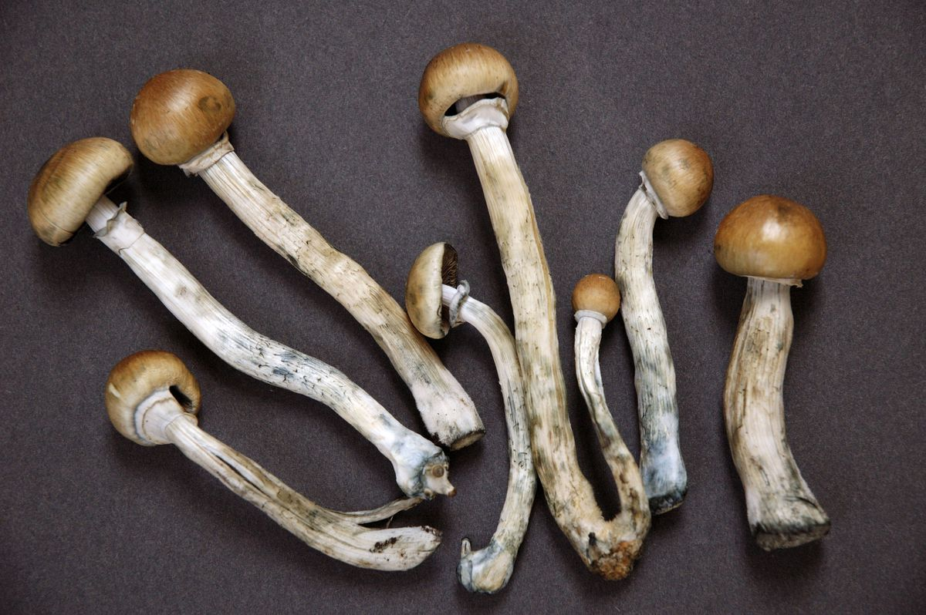
Magic mushrooms. (Photofusion / Universal Images Group via Getty Images)
Risks: The main risk of LSD and psilocybin, which is found in magic mushrooms, is that they can cause some people, particularly those using other drugs or with a family history of mental health issues, to have psychotic episodes, a lost sense of reality, and even long-term psychological trauma in very rare situations.
Hallucinogen Persisting Perception Disorder (HPPD) can also lead to problems with vision, such as flashes of colored dots, shimmering lights, and shakiness. These are typically characterized as disturbances, but they can cause emotional distress among some people. Charles Grob, a UCLA psychiatrist focused on hallucinogen research, said HPPD is "uncommon, but you will see it, particularly among someone who has taken hallucinogens a lot."
There's also a risk of accidents. Since these drugs have such a powerful effect, there's always a possibility that people in an uncontrolled or chaotic environment will do stupid things. The typical example is someone jumping off a roof because he thinks he can fly, but less extreme accidents — like falling down stairs or running into incoming traffic — are also possible.
Some of these problems may be more prominent with LSD than psilocybin. Both drugs have fairly similar effects, but LSD lasts much longer, potentially making it more difficult to remain calm and keep control during an LSD trip.
Hallucinogen overdose deaths are "almost unheard of," Grob said, but bad trips can lead people to get into fatal accidents.
Unlike most other drugs on this list, the addictive risk to LSD and mushrooms is low to nonexistent.
Why people do it: LSD and mushrooms can lead to a pleasurable high that can literally change how someone views the world for the better. Researchers believe hallucinogens in controlled medical and spiritual settings may be able to treat alcoholism, anxiety, obsessive compulsive disorder, and even nicotine addiction. A small study found psilocybin, the active ingredient in magic mushrooms, got 80 percent of participating smokers to quit. Some experts, including Kleiman of UCLA, says these drugs could even benefit perfectly healthy people.
Bottom line: Hallucinogens are among the safest drugs in terms of abuse, since they pose little-to-no risk of addiction and rarely cause major mental and physical health problems. In tightly controlled settings, they can have an enormous, untapped potential for people suffering from serious mental health issues.
Still, using LSD and psilocybin outside controlled settings can lead to very bad experiences, which can in very rare cases have a permanent — although not deadly — effect on people prone to mental illness and disorders. And since the effects of these drugs is so strong, people can get in severe accidents that could injure or kill them.

MDMA (ecstasy or Molly)
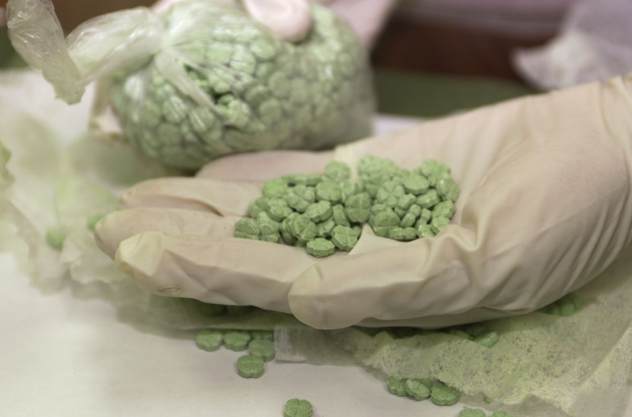
Ecstasy pills. (US Customs via Getty Images)
Risks: The most serious adverse effects caused by MDMA, also known as ecstasy or Molly, are dehydration and elevated body heat. These conditions can lead to heat stroke, particularly in party or rave settings, where MDMA is often used, in which a lot of people are close together and engaging in heavy physical activity.
MDMA can also lead to other short-term problems, such as increased blood pressure and heart rate, nausea, and restlessness. It can also cause psychotic breakdowns for some people, particularly those with a history of mental illness.
But perhaps the biggest risk of MDMA is that it's largely purchased in the illicit black market, where the drug can be mixed with all sorts of dangerous substances — and in some cases might not be MDMA at all. "Reliability of black-market ecstasy is extremely poor, probably the poorest of any drug around," Grob said.
Unlike most other drugs on this list, the addictive risk to MDMA is low.
Why people do it: The high caused by MDMA can produce huge feelings of euphoria that make everything feel better. Developing research is looking into whether MDMA can be used in guided medical and spiritual settings to treat mental health problems, particularly PTSD.
Bottom line: MDMA is one of the safer drugs on this list, although it can cause serious problems in the short-term if it's not used in a safe, controlled setting. Since it poses little risk of addiction compared to other drugs, concerns about drug abuse are also much less pronounced with MDMA.

